

|  |  |  |
| --- | --- | --- |
| Mathematics Department | |  |
| Course: A2MAA | |
| Topic Title: Test 1 | |
| Student Name:_____________________________________ | Date: ____________ | | |
| Special Instructions: Formula Sheet, 1 page of double sided A4 notes and calculators allowed. | Time Allowed: 60 minutes | | |
|  | Marks: / 55 | | |

**Question 1.**

Consider the frequency table shown below:

|  |  |
| --- | --- |
| **Score** | **Frequency** |
| 16 | 2 |
| 17 | 4 |
| 18 | 3 |
| 19 | 1 |
| 22 | 2 |
| 23 | 3 |
| 49 | 1 |

1. Calculate the mean, median, mode and standard deviation of the above scores. [4 marks]
2. The score of 49 has been identified as an outlier. Remove the outlier and recalculate the mean and standard deviation. [2 marks]
3. What effect did removing the outlier have on the mean and standard deviation and why? [2 marks]

**Question 2.**

A student named Ian from a large school is investigating the weights of boys in his year group.

(a) Circle the best **two,** of the four methods outlined below, to pick a **fair and unbiased** sample of boys to weigh from his year group. [2 marks]

* 1. Choose the first five of his friends he talks to.
  2. Randomly pick the names of 20 students from a list of all students in his year group.
  3. During a year assembly, ask for 20 students to volunteer.
  4. Stand at the main school entrance before school starts and write down the name of every third boy from his year group who arrives.

Ian weighed 24 students and their weights, in kg to one decimal place, are listed below.

65.2, 60.0, 62.8, 63.8, 58.9, 65.9, 69.0, 65.5, 67.9, 62.7, 58.4, 69.4

73.2, 66.3, 65.5, 64.4, 56.5, 63.4, 60.1, 56.3, 59.9, 64.7, 61.9, 63.6

(b) For these 24 weights, determine the range. [1 mark]

(c) Group this data, using the class intervals in the table below. [2 marks]

|  |  |
| --- | --- |
| Weight of boy (kg) | Frequency |
|  |  |
|  |  |
|  |  |
|  |  |
|  |  |
|  |  |
|  |  |
|  |  |

(d) Which is the modal class for the data in the frequency table? [1 mark]

(e) Use the grouped data from (c) to construct a frequency histogram on the axes below. [4 marks]



(f) Describe two features of the spread of weights shown in the histogram. [2 marks]

(g) Calculate an estimate of the mean using your histogram drawn above. [2 marks]

(h) Explain why your answer to part (g) is only an **estimate** of the mean? [1 mark]

**Question 3.**

Solve the following:

a) $\frac{3x-7}{4}= 3.5$ [2 marks]

b) $6+0.5x=20+4x$ [2 marks]

**Question 4.**

Determine the equation of the linear relationship between $x$ and $y$ in the form $y=Mx+C$

|  |  |  |  |  |  |
| --- | --- | --- | --- | --- | --- |
| $$x$$ | 2 | 3 | 4 | 5 | 6 |
| $$y$$ | 4.5 | 5 | 5.5 | 6 | 6.5 |

a) [2 marks]

b) [2 marks]

|  |  |  |  |  |  |
| --- | --- | --- | --- | --- | --- |
| $$x$$ | 0 | 2 | 4 | 6 | 8 |
| $$y$$ | 9 | 5 | 1 | -3 | -7 |

**Question 5.** [4 marks]

Use your calculator to generate a table of values for the equation and graph the line below.

$y=0.75x-3$

|  |  |  |  |  |  |
| --- | --- | --- | --- | --- | --- |
| $$x$$ | -2 | -1 | 0 | 1 | 2 |
| $$y$$ |  |  |  |  |  |



**Question 6.**

A full water storage tank is punctured and beings to slowly leak water.

The volume of the tank (*V*) in litres is 600 and the tank leaks 12 litres per hour (*t)*

1. Write a linear equation to describe the situation above. [1 mark]

b) What is the tank’s volume after 6 hours? [2 marks]

c) How long will it take for the tank to lose half its initial volume? [2 marks]

d) What is the total time taken for the tank to completely empty? [1 mark]

**Question 7.**

State the gradient and y intercept of the following functions

1. $y=5x-3.5$ [2 marks]
2. $-12x-3y=60$ [3 marks]

**Question 8.** [2 marks]

Write the equation of the line that passes through (1,4) and (4,22).

**Question 9.**

An emergency locksmith in the city has a fee structure for jobs performed between 12am and 6am as shown in the graph below where y represents the amount in $ and x represents the time in minutes.

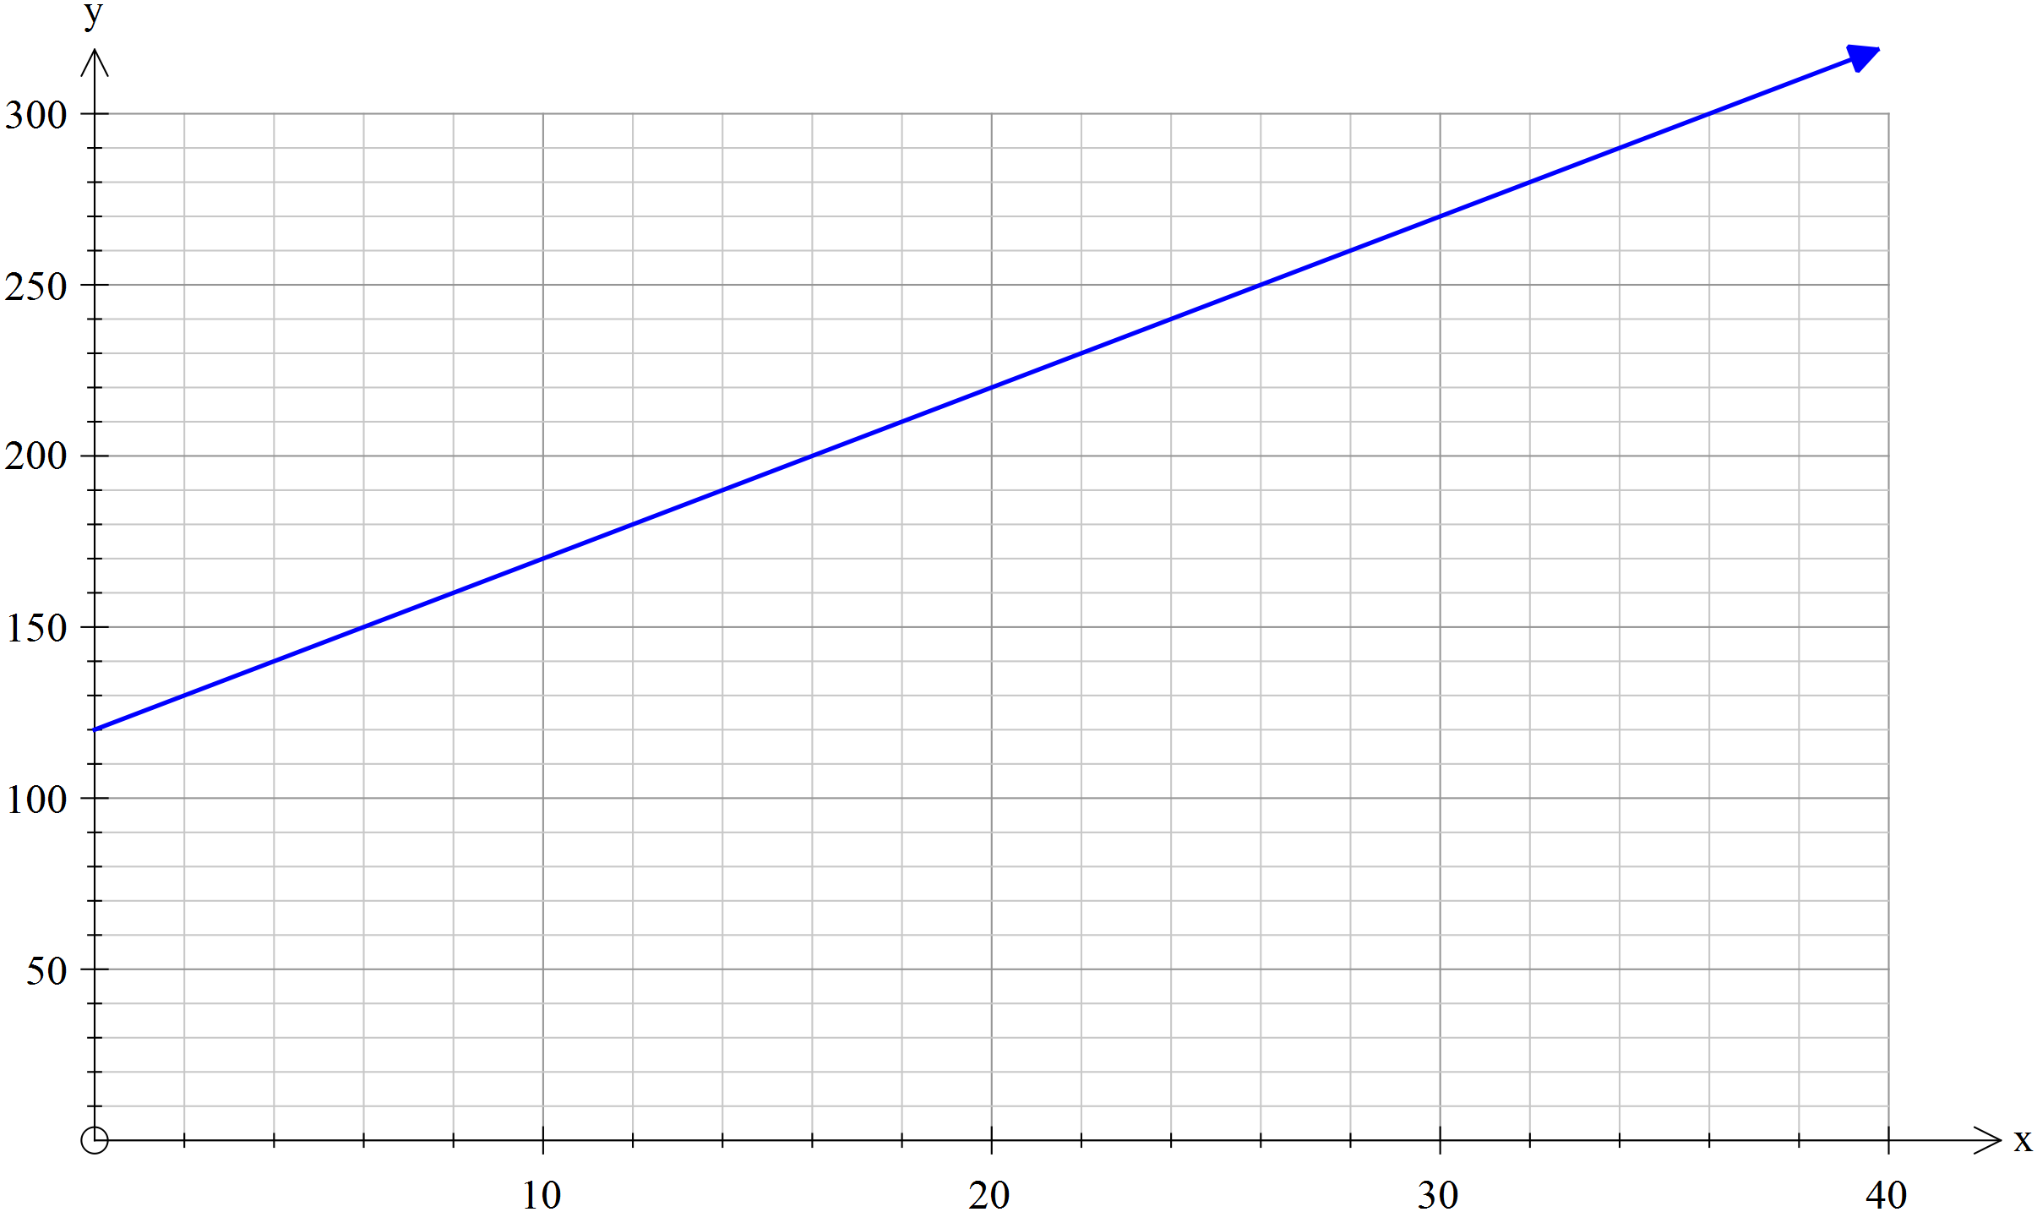

1. From the graph, determine the call out fee charged by the locksmith. [1 mark]
2. From the graph, calculate the charge per minute. [1 mark]
3. Calculate the amount charged by the locksmith for a 20 minute job. [1 mark]
4. What is the gradient of the line in the graph? [1 mark]
5. What is the y intercept of the line in the graph? [1 mark]
6. Write an equation for the line in the graph. [1 mark]
7. Calculate the amount charged by the locksmith for a 50 minute job. [2 marks]